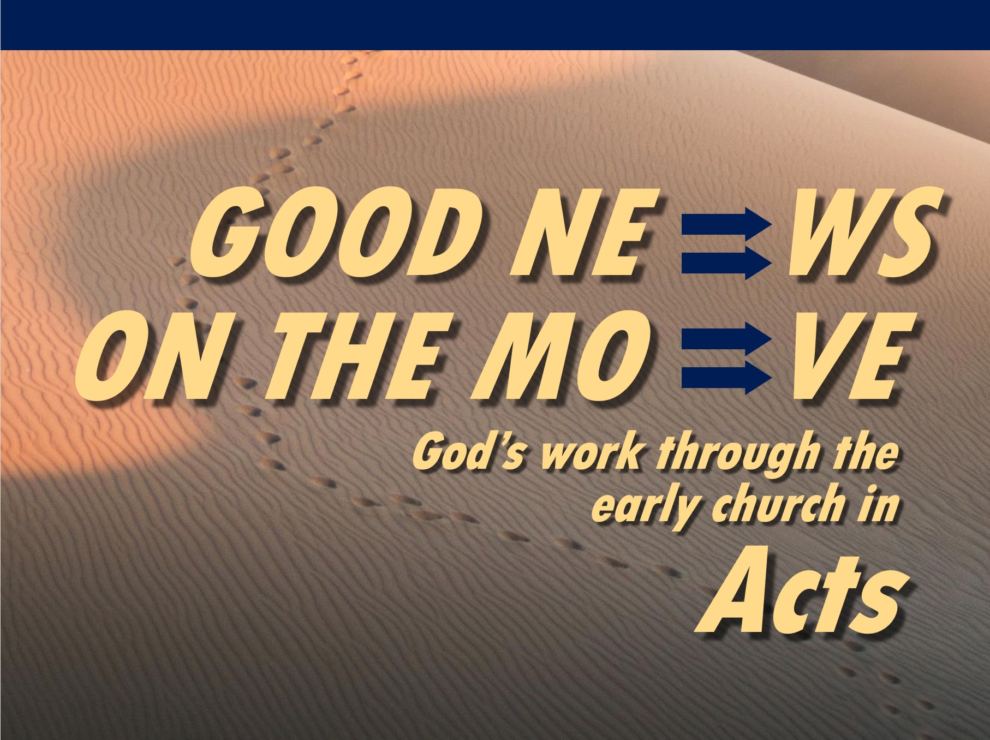

Rick Griffith
6 June 2021
Message 19 of 23

Elder Roles
Acts 20

Introduction

What’s an elder to do?

Paul modeled the elder lifestyle before he preached it to others.

I. Paul modeled shepherding for the elders (20:18b-27).

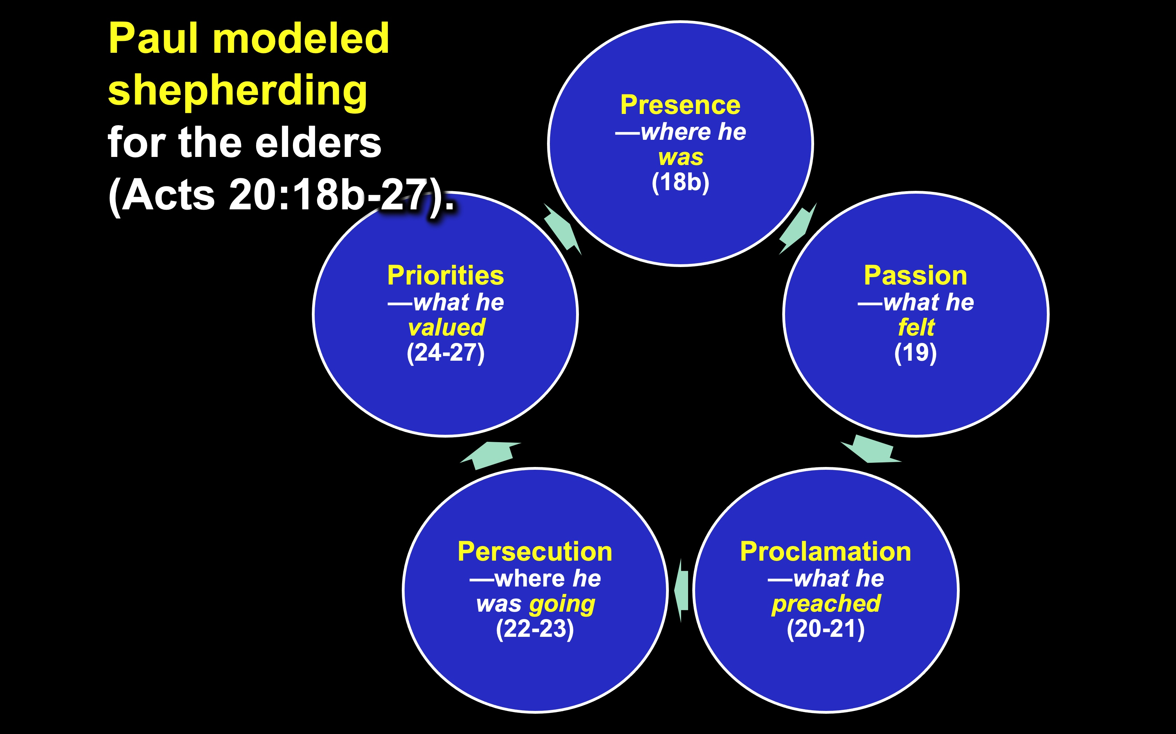

II. Elders should follow Paul’s shepherding example (20:28-35).

Elders have shepherding tasks to lead the church (28).

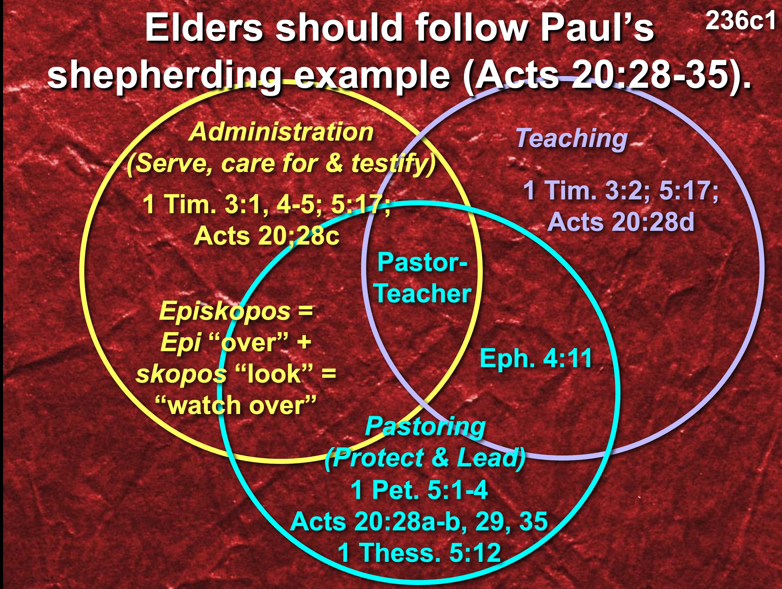

These tasks will protect the church from false teachers (29-31).

External false teachers will destroy some believers (29).

Internal false teachers will draw some away from Christ (30-31).

Elders must serve selflessly (32-35).

Selfless service is founded on God’s grace and Word (32).

Selfless service is based on hard work instead of greed (33-35).

Conclusion

Elders should be selfless shepherds against false teachers
(Main Idea).

Watch Paul and mimic Paul!

How can you better shepherd the flock under your care—whether the whole church as elders, or our families, or friends?

Download this sermon PPT and notes for free at BibleStudyDownloads.org/resource/new-testament-preaching/

