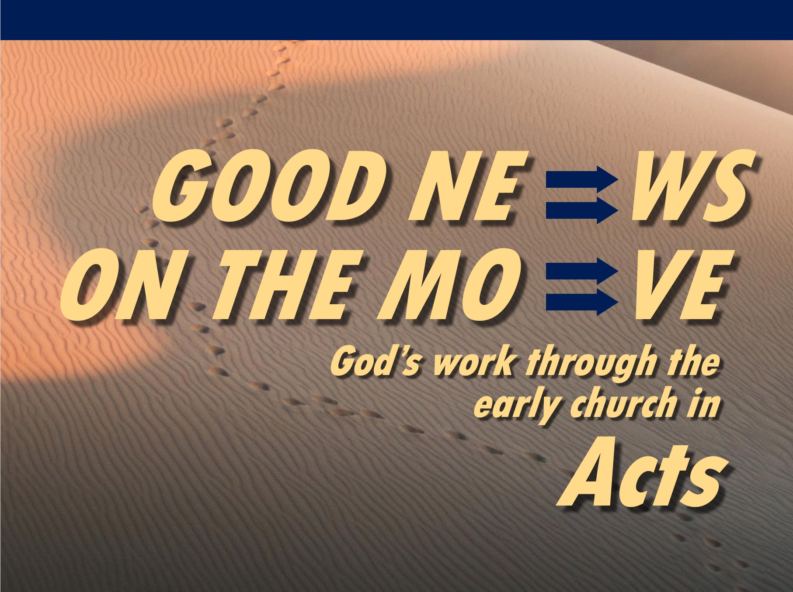



**Rick Griffith**

30 May 2021

Message 18 of 23

**The Peaceful Riot**

***Acts 19:21-41***

# Introduction

### Christians are increasingly falsely accused of disturbing the peace.

### Who brings peace in society more—believers or unbelievers in Jesus?

### Unbelievers in the Roman Empire in the AD 50s-60s suspected Christians to be troublemakers—but Paul made plans to leave Ephesus peacefully (19:21-22).

# I. The idol maker Demetrius began the Ephesus riot—not the peaceful Paul (19:23-41).

## The idolater Demetrius accused Paul of trouble-making and apostasy (19:23-27).

### Demetrius stirred up craftsmen against Paul cutting their profit from idols (19:23-27a).

### But Demetrius also said that he sought the honor of Artemis (19:27b).

## Demetrius caused the riot—not Paul—whom the clerk defended (19:28-41).

### The attack from Demetrius led to a two-hour riot in the theater (19:28-34).

### The clerk wisely calmed the crowd by defending both Artemis and Paul (19:35-41).

#### He enticed their pride, saying Ephesus guarded Artemis from heaven (19:35-36).

#### He cleared Gaius and Aristarchus (and, in effect, Paul) of any crime (19:37).

#### He encouraged legal charges, knowing the crowd wouldn’t do it (19:38-39).

#### He warned that Rome might hear of their riot and punish the city (19:40-41).

**II. Believers bring peace in society (Main Idea).**

## Idolatry leads to trouble.

### The Ephesus uproar proved Christianity innocent of wrongdoing but idolatry useless.

### Not all idols are gold, silver, and wood. Ezekiel 14:3-6 warns of the idols of the heart. An idol is anything that takes God’s place.

## The gospel leads to peace.

### Idolatry brings turmoil; Christianity brings peace.

### Belief in Jesus divides families but also brings harmony today.

#### “I will bring a sword”—Jesus

#### “Peace I leave with you”—Jesus

# Conclusion

### Believers bring peace in society (Main Idea).

### How can you exchange idols for peace in your own situation?

#### Do you have any idols of the heart?

#### In what ways do you promote peace in society?

#### In what ways do you disturb peace in society?

### “He is Our Peace” tells us to cast all our cares on Jesus.

Download this sermon PPT and notes for free at BibleStudyDownloads.org/resource/new-testament-preaching/