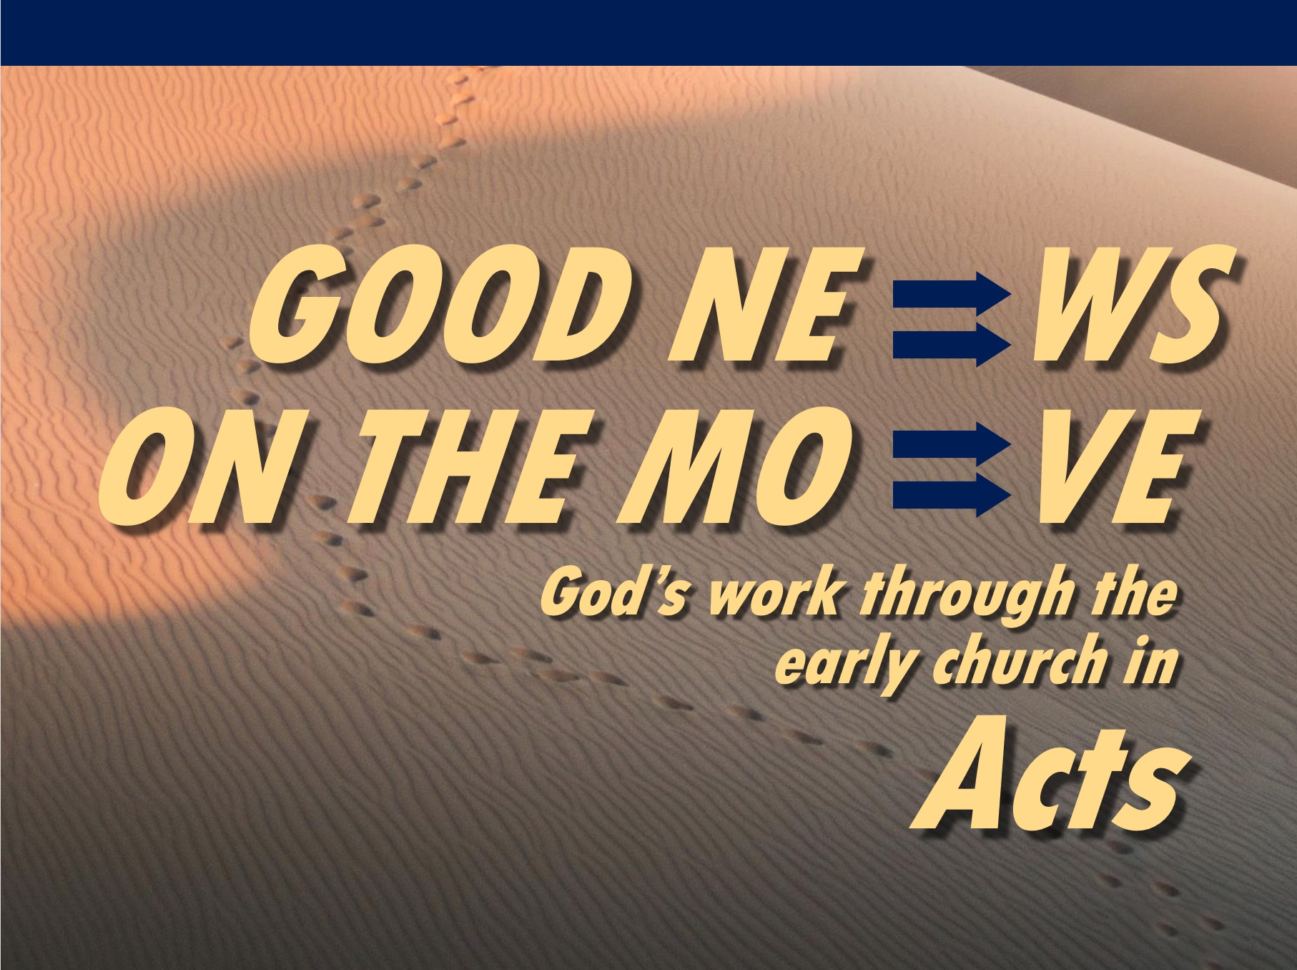
Matt Lyle
25 April 2021
Message 13 of 23

Going on a Journey
Acts 12:25 – 14:28

Introduction

The Book of Acts shows God’s church growing despite external and internal opposition.

We are part of God’s plan in growing the church.

How can you do the impossible?

I. Seek out the Holy Spirit (12:25–13:3).

Early church sought the Holy Spirit for guidance (11:29-30, 12:25).

Pray and seek God’s guidance in your life (13:1-3).

(Seeking counsel of the Holy Spirit is half the equation. What is the other half?)

II. Follow the Holy Spirit (13:4 – 14:28).

In Paphos: The Holy Spirit overcame Elymas the Magician (13:4-12).

In Antioch of Pisidia: The Holy Spirit empowered Paul to preach the Gospel to the entire city (13:13-52).

In Lystra: The Holy Spirit empowered Paul to heal a man crippled from birth and to survive being stoned (14:8-20).

When returning to Antioch of Syria, the Holy Spirit enable the apostles to establish self-governing, self-propagating, and self-sustaining churches.

(How can you do the impossible?)

Conclusion

Seek out and Follow the Holy Spirit (Main Idea).

What areas of your life do you need to seek the Holy Spirit?

What areas of your life do you need to follow the Holy Spirit?

Download this sermon PPT and notes for free at BibleStudyDownloads.org/resource/new-testament-preaching/

