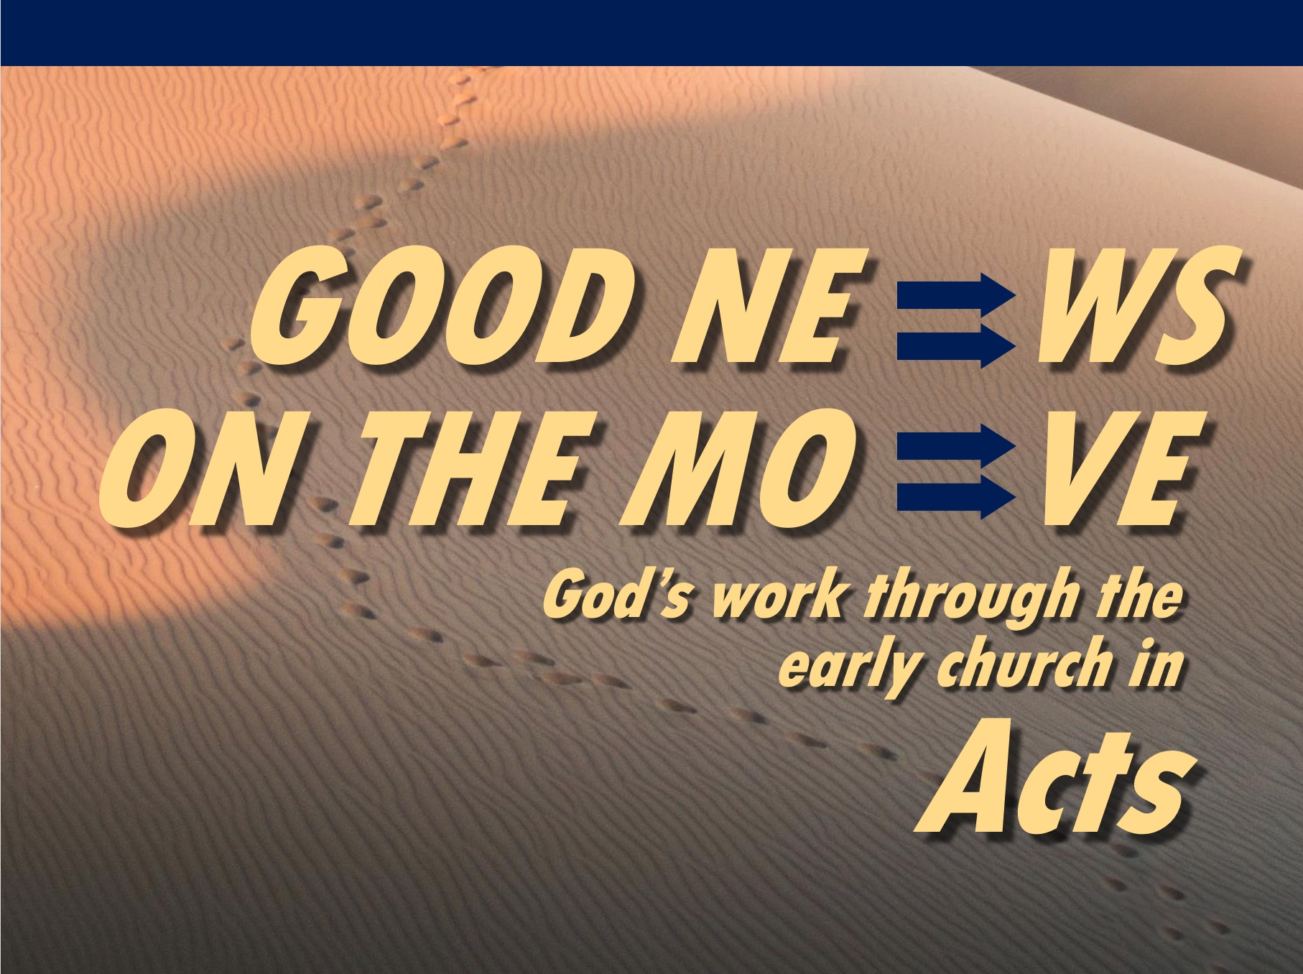
Rick Griffith
18 April 2021
Message 12 of 23

Our Unstoppable God
Acts 12:1-24

Introduction

Acts shows a pattern of Jewish rejection.

But no one can stop God’s plan to save humanity as He is the Unstoppable God.

How did the Jews continue to reject Jesus?

I. Herod opposed Christ (12:1-22).

Herod murdered James (12:1-2).

Herod imprisoned Peter unsuccessfully (12:3-19).

Herod accepted worship that only God deserves (12:20-22).

(So what happened as a result? How did God respond to these who rejected the gospel?)

II. God judged Herod but prospered the church (12:23-24).

Herod died by being eaten by worms (12:23).

The church grew both in numbers and geographically (12:24).

III. God judges oppressors while expanding his church (Main Idea).

He uses difficulty to help us love him.

Often the places of greatest trial are the places of greatest growth.

(How does God respond today to those who reject the gospel?)

Conclusion

God judges oppressors while expanding his church (Main Idea).

How will you trust in God’s timing and way to deal with those who reject him?

Are you suffering for Jesus right now?

How can your difficulties propel you to greater growth?

Will you let God deal with his opposers as he wishes?

Download this sermon PPT and notes for free at BibleStudyDownloads.org/resource/new-testament-preaching/

