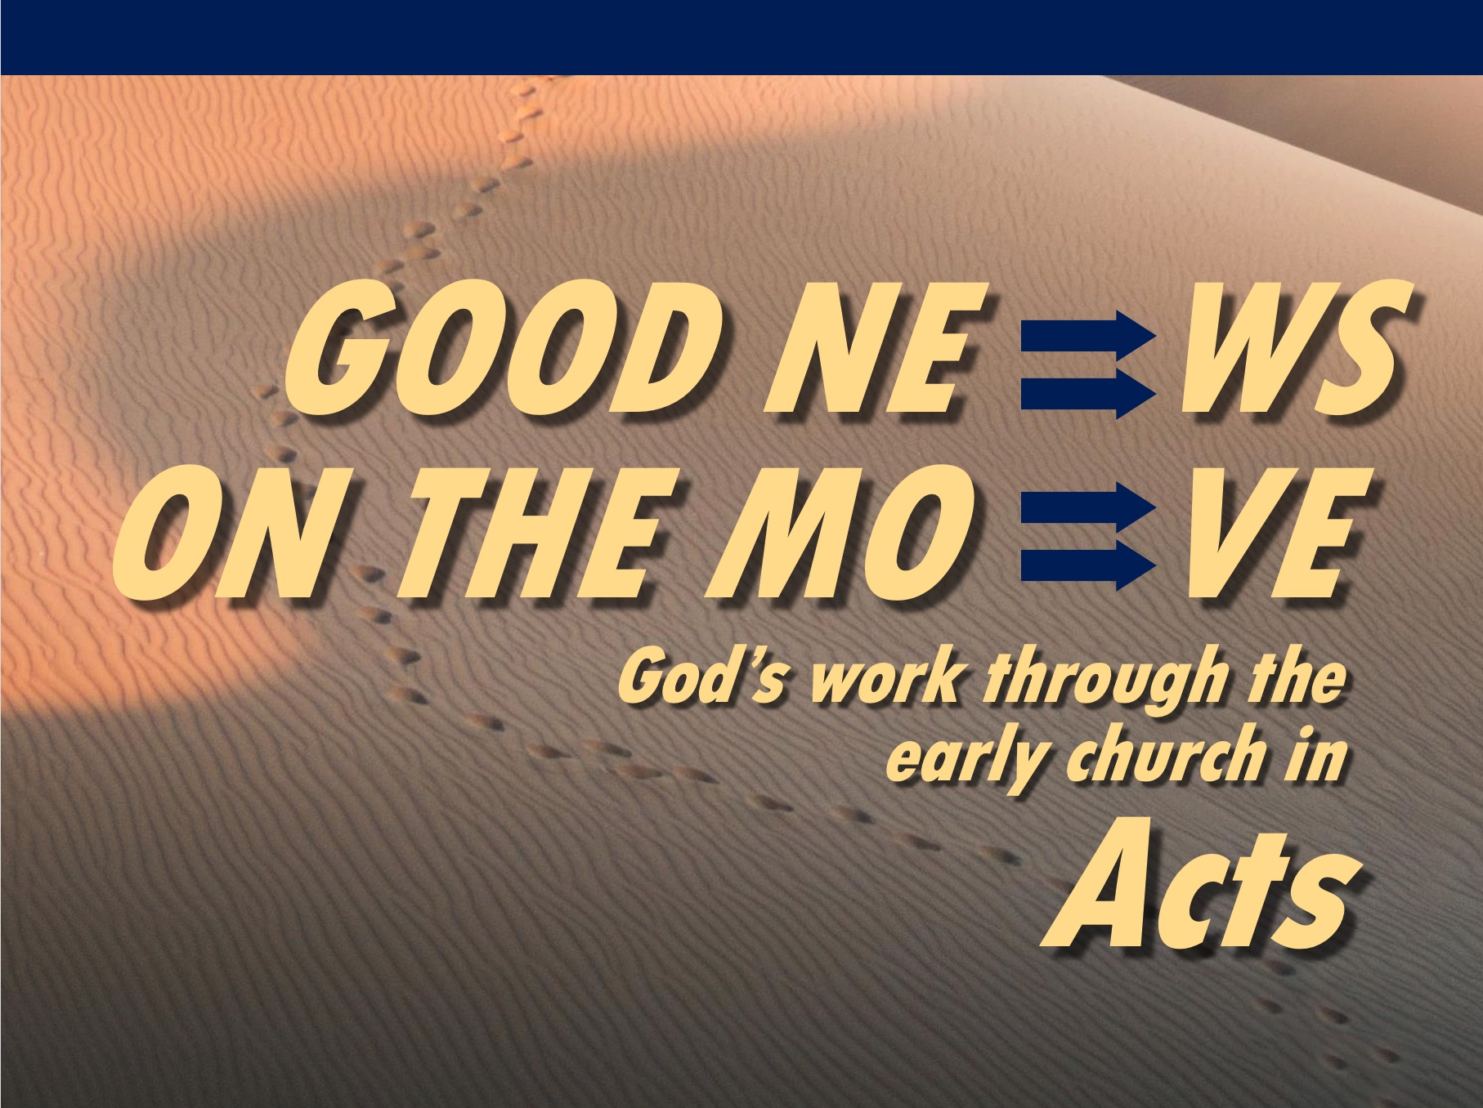
Rick Griffith
21 Feb 2021
Message 4 of 23

Obey God—Not Man
Acts 4:1–5:11

Introduction

It’s no secret that not everyone is exciting about us being Christians.

How do you respond when there is a price to pay for your faith?

How should we respond to the challenges that our faith in Christ brings?

I. When unbelievers oppose you, obey God—not man (Acts 4:1-31).

External opposition from the Sanhedrin led the church to obey God—not man (4:1-31).

Commit now to obey God before temptations by unbelievers to obey man become too strong.

II. When believers oppose you, fear God—not man (Acts 4:32–5:11).

Internal deception by Ananias and Sapphira caused a fear of God (4:32–5:11).

Let deceit by believers lead you to fear God.

Conclusion

Obey God rather than people (Main Idea).

Say aloud, “I will ultimately account to Jesus himself for my life—not to people.”

This realization moves me to make hard decisions.

Where is God telling you to “obey God—not man”?

Download this sermon PPT and notes for free at BibleStudyDownloads.org/resource/new-testament-preaching/

