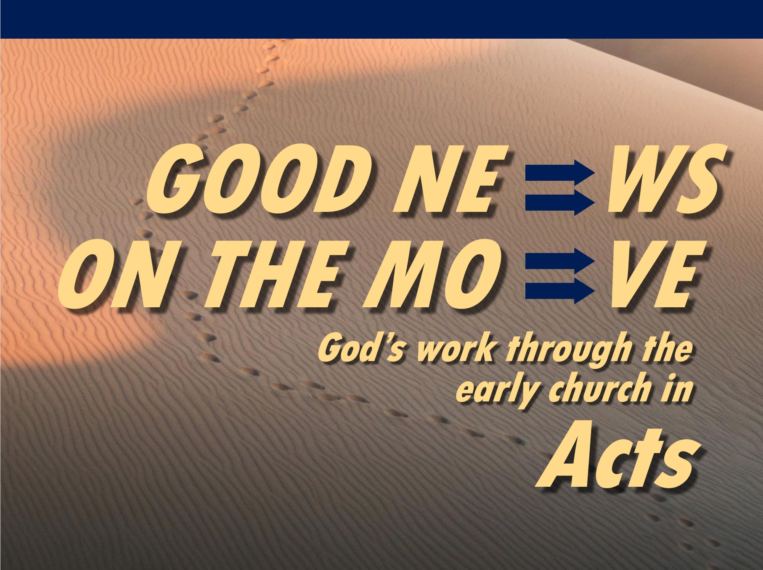

Rick Griffith
14 Feb 2021
Message 3 of 23

Why God Does Amazing Things
Acts 3

Introduction

Video of Acts 3:1-10 (https://www.youtube.com/watch?v=AT7cnOkGcBQ)

Why is this story in Acts? Notice the emphasis on the name of Jesus in this account…

I. Peter shared the gospel after healing a lame man in Christ’s name (Acts 3).

Peter healed a lame man in Jesus’ name (3:1-10).

Jesus healing the cripple enabled Peter to share the gospel (3:11-26).

Jesus could heal the cripple because he died and rose again (3:11-16).

The people should accept Jesus as Israel’s promised king (Christ = Messiah) who will return to restore the kingdom after the nation believes (3:17-26).

II. Seeing God work gives us open doors for witness (Main Idea).

Speak the name—thus the authority—of Jesus.

Peter healed the man in the name of Jesus (3:6).

Peter refused to take any credit for power or godliness (3:12).

Peter said that the man placed his faith in the name of Jesus (3:16).

I wonder how much you and I talk about Jesus instead of ourselves!

What amazing things has God done where you have a front-row seat?

He rescued me from a broken home and used me for his work for 41 years.

He’s helped me increasingly see that I have too low a view of Jesus.

Conclusion

Seeing God work gives us open doors for witness (Main Idea).

How are you seeing God work in your life?

How can you give Jesus credit for his work?

Download this sermon PPT and notes for free at BibleStudyDownloads.org/resource/new-testament-preaching/

